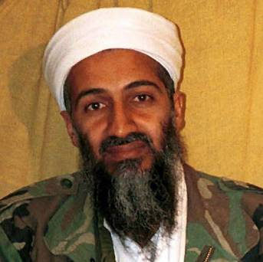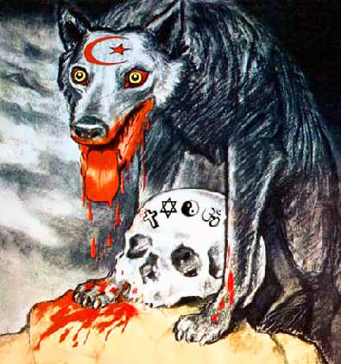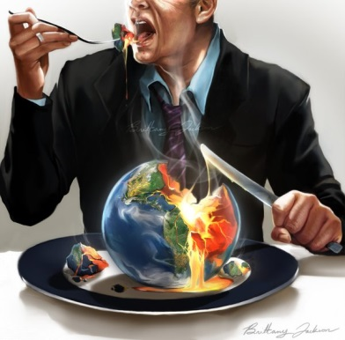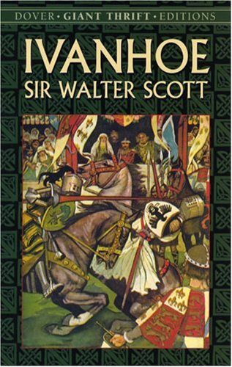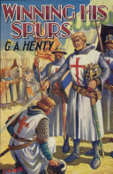[](http://www.google.co.uk/url?sa=i&rct=j&q=winning+his+spurs+book&source=images&cd=&cad=rja&docid=gruqF4czshAcjM&tbnid=FzMH9supyAwSYM:&ved=0CAUQjRw&url=http://books.google.com/books/about/winning_his_spurs.html?id=94esYPXOyTgC&ei=K5i0UZCIC-Oj0QXdtoDgBQ&bvm=bv.47534661,d.d2k&psig=AFQjCNGalq9MBxS-plKF_jwMGPaZzLMBRQ&ust=1370876319222018)

**CARD 19: Modern extremist view**

Osama bin Laden called the Americans 'Crusaders' in his speeches on the Internet. Others like Saddam Husain said he was descended from Saladin.

**CARD 18: Defensive Interpretation**

In recent times, there has been a growing opinion that the Crusades were defensive – a reaction to Muslim aggression – and that they were not as violent as had been claimed.

**CARD 17: Negative Interpretation**

Some 20th Century writers have criticised the Crusades for being an aggressive and colonial expansion. Greed for power and land being the motivation.

**CARD 16: Positive Interpretation**

Writers in Britain like **Sir W Scott and GA Henty**, produced a romantic, chivalric interpretation of the Crusades - a meeting of noble warriors on both sides who respected each other.